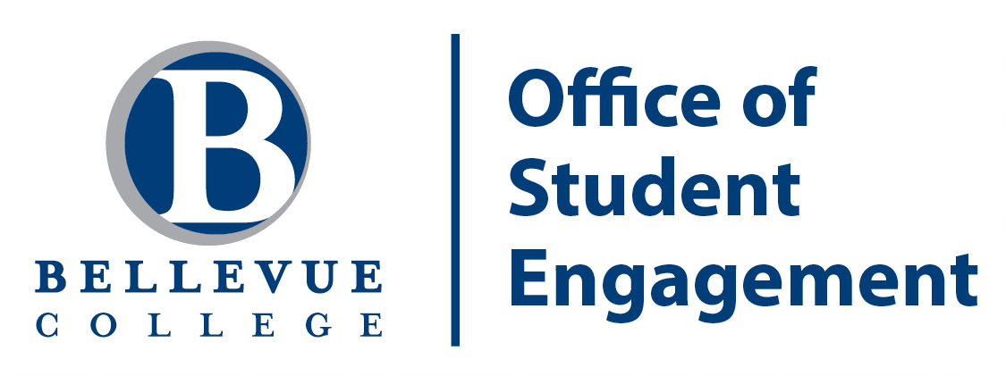

Bellevue College Office of Student Engagement

# 2022-2023 Student Affinity Coordinator Job Description

**Position Summary**

The Bellevue College Office of Student Engagement (formerly known as the Office of Student Programs), is committed to enriching student life by providing engagement and leadership opportunities that empower our students to find their passion, build community, and grow to be better world citizens who contribute to a vibrant and diverse campus culture.

We work to support students and student organizations, with the goal of creating an environment that promotes cultural awareness, inclusivity, personal accountability, and respect. By helping students learn about themselves and actively engage with others, we believe this enhances the overall college experience.

Student Engagement also provide events, activities, and outlets for purposeful involvement with a student development-centered approach, and the commitment to foster student success academically, personally, and professionally. We oversee the Student Business Center, The Watchdog student newspaper, advise the Associated Student Government and manage the Campus Activities Board.

The Student Affinity Coordinators support student organizations (clubs, unions, associations, etc.) in their respective student demographic, manage the Student Affinity Resource Centers in C212, plan and host events on behalf of students from traditionally underserved populations, collaborate with other Affinity Coordinators, celebrate culture and heritage, raise awareness, and build community, all while embodying the College’s Affirmation of Inclusion.

The successful candidate will demonstrate a commitment to Bellevue College’s mission, values, and a sensitivity and care for students and guests from diverse backgrounds, experiences, and identities; and the proven ability to effectively balance academic, work, and personal responsibilities.

The following covers these student positions in the Office of Student Engagement:

**Arabic Students Affinity Coordinator**

**Asian-Pacific Islander Students Affinity Coordinator Black Students Affinity Coordinator**

**International Students Affinity Coordinator Latinx Students Affinity Coordinator LGBTQ Students Affinity Coordinator Veteran Students Affinity Coordinator**

# Qualifications and Requirements

**Academic Standing**

At the time of hire, students must:

Be enrolled in at least 7 credits at Bellevue College.

Be in good standing with the College as far as Student Conduct While in the position, students must…

Be enrolled in at least 7 credits at Bellevue College each quarter (except summer) Maintain a GPA of 2.5 or greater

Remain in good standing with the College as far as Student Conduct

# Compensation

For Summer/Fall 2022 – Spring 2023:

* 10-15 hours a week at $14.49 per hour.

# Student Affinity Coordinator Position Responsibilities

**Community Building and Support**

* Work with and support identity-based student organizations that fall under their Affinity Group: attend these organizations’ meetings, help with their events, assist officers with planning; promote a collaborative, inclusive environment and build community.
* Co-manage the Student Affinity Resource Center in the Office of Student Engagement with the other Student Affinity Coordinators: keep office hours, welcome visitors and provide resources for all identity-based groups; create and maintain an inclusive space for students.
* Represent the Office of Student Engagement and their Student Affinity Group. Advocate on behalf of their Student Affinity Group, and their constituent student organizations. Promotes culture and events, and further inclusion.
* Identify and offer assistance to students who seek resources, have questions, concerns, or who need general assistance. Refer students as necessary to appropriate professional staff.
* Works collaboratively with other Student Affinity Coordinators, student employees, professional staff with the Student Engagement Office and the broader BC campus community.

**Event Planning and Management**

* Plan, promote and host events throughout the academic year that support the mission statement of the Office of Student Engagement with respect to their Student Affinity Group.
* Set student learning outcomes during planning, and evaluate events and initiatives to improve community engagement

**Administrative Tasks**

* Maintain effective and regular communication with the Associate Director and the Director of Student Engagement
* Monitor their Services and Activities (S&A) Fee budget with the Assoc. Director of Student Engagement.
* With supervisor, creates the next fiscal year S&A budget each Spring
* Maintain the log and manages the front desk of the Student Affinity Resource Space
* Respond to in-person and phone questions and concerns in welcoming and inclusive manner.
* Maintains an inventory of resources for students from traditionally underserved populations.
* Participates in staff meetings, supervisory meetings, and provided training opportunities, when required or requested by professional staff.

For questions about the Student Affinity Coordinator positions or application process please contact [studentengagement@bellevuecollege.edu](mailto:studentengagement@bellevuecollege.edu)